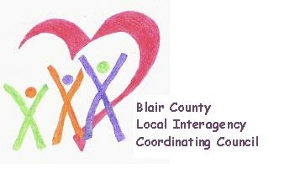

Local Interagency Coordinating Council

Agenda for September 19, 2024
Zoom meeting
9:30 am

- Welcome and Introductions
- Review May meeting minutes
- Policy and Procedure
- Child Find/Service Delivery
- Membership
- Education and Training
- Agency updates
- Other

2024-2025 meeting schedule
(Meetings will be held at 9:30 am via Zoom)

September 19, 2024
November 21, 2024
January 16, 2025
March 20, 2025
May 15, 2025

